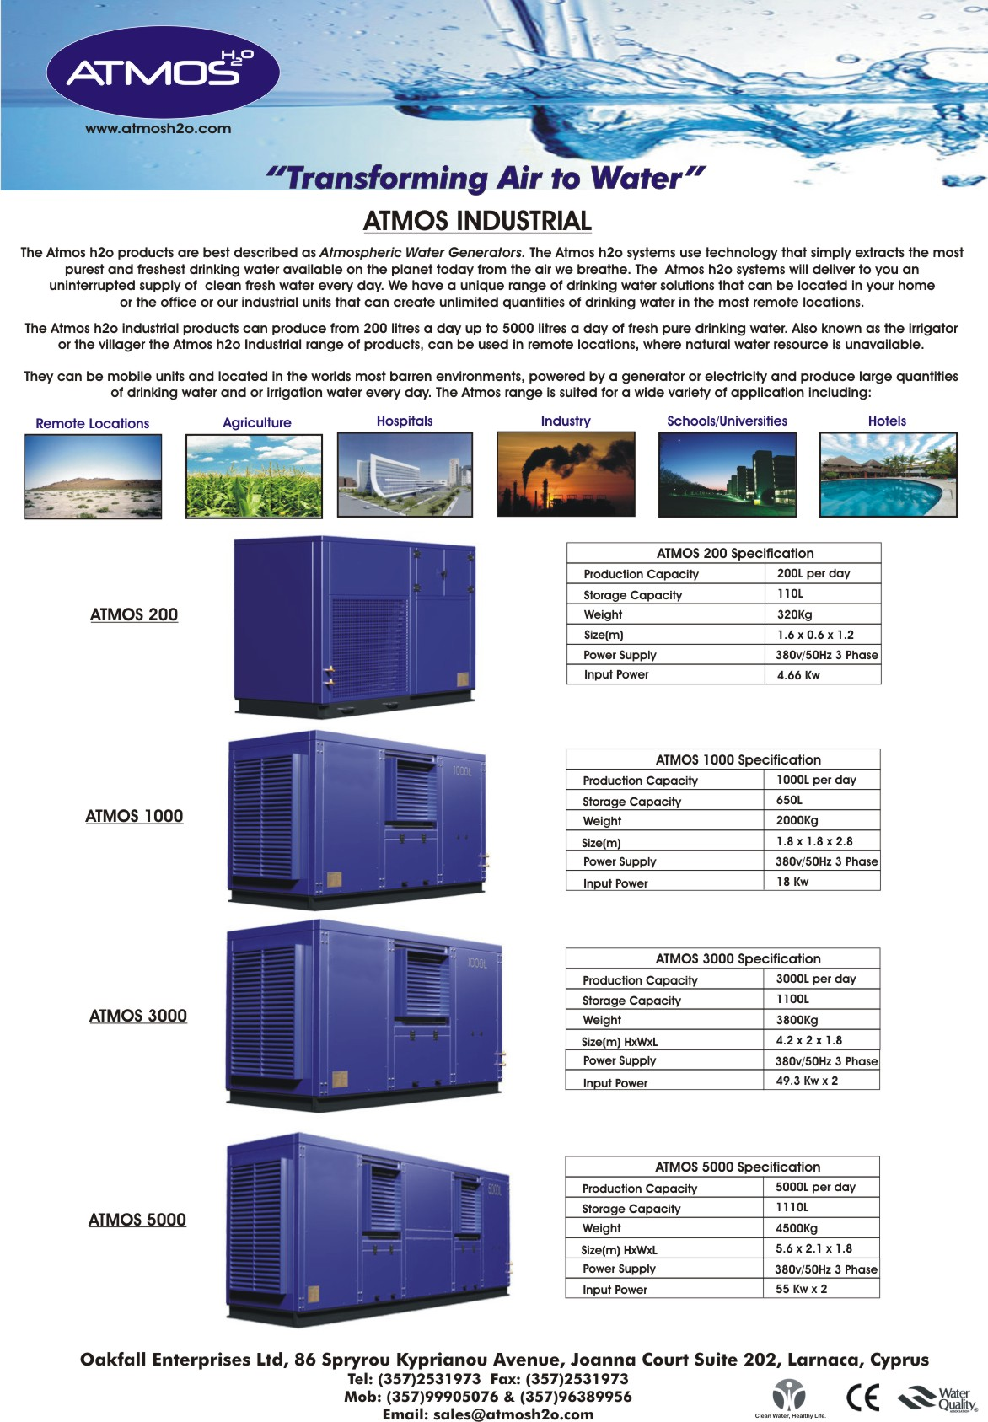



FCWG5000
FCWG1000
FCWG3000
FCWG200
FCWG 200 Specification
FCWG 1000
FCWG 3000
FCWG 5000
FCWG 1000 Specification
FCWG 3000 Specification

