Model Number: FCWG100
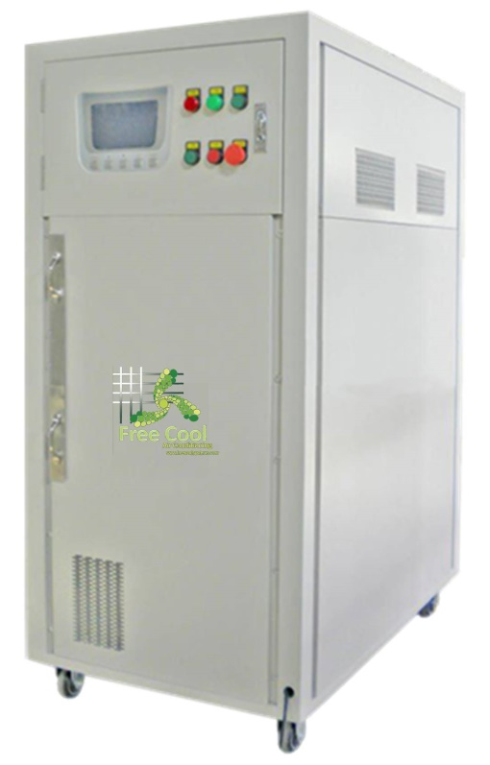

Quick Overview
• Power: 220V/50Hz / 110V/60Hz
• Total Wattage: 2.1KW
• Production Capacity(30℃ 80%): 100L/day
• Storage Capacity: 100L
• Temperature Range: 15-40℃
• Humidity Range: 35%-95%
• Weight: 190Kg
• Size: 65*105*142cm
• Color Available: White, Blue

Features:

•Super large LCD touch screen, user-friendly design, intuitive and convenient operation.
•The machine is a new, state of the art water generating machine which takes moisture out of thin air and turns it into pure drinking water.
•The multi-stage filtration system not only effectively removing the acid characteristics contain the necessary microelement and minerals.5 stages filtration system. The reverse osmosis is imported from USA and Korea.
•The multi-stage filtration system ensures the purest drinking water by using the “reverse osmosis “technology and the “ultra violet “lights in the circulation system.

Specification:

Item No.: | FCWG100 | The Free Cool Water Generator:  This technology enables users to create up to 500 liters of pure drinking water, right out of the atmosphere each day, requiring no inlet water supply (water supply line). Our system comes in three different capacities. Each model can be placed on top of building as well as on ground level. In addition, the machine are saleable. This means they can be placed in sequence to fulfill the most sizable water requirements.
Power: | 220V/50Hz / 110V/60Hz
Total Wattage: | 2.1KW
Production Capacity | (30℃ 80%): 100L/day
Storage Capacity | 100L
Temperature Range | 15-40℃
Humidity Range | 35%-95%
Weight | 190Kg
Size | 65*105*142cm
Color Available | White, Blue
