Model Number: FCWG1000

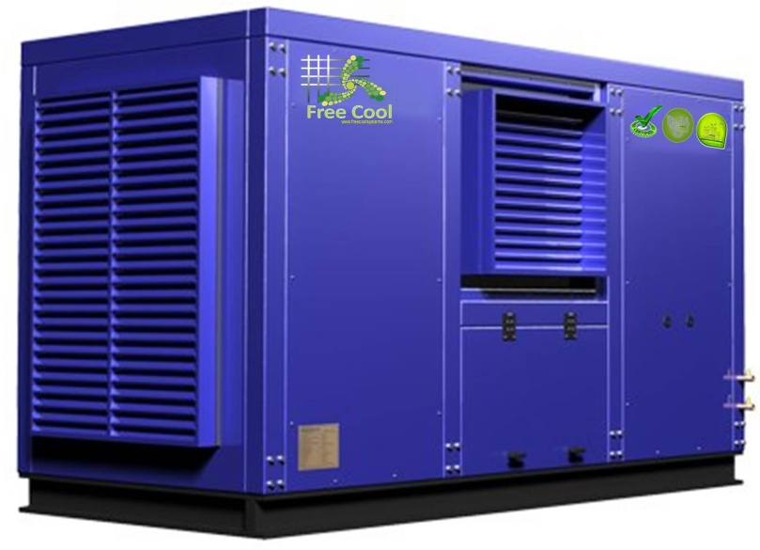
Industrial or Commercial Atmospheric
Water Generator with Production Capacity of 1000L/Day

Quick Overview
• Power: 220V/50Hz / 110V/60Hz
• Total Wattage: 9.9KW*2
• Production Capacity(30℃ 80%): 1000L/day
• Storage Capacity: 650L
• Noise Level : <79DB
• Humidity Range: 35%-95%
• Weight: 2000Kg
• Size: 180*180*280 cm
• Color Available: White, Blue

Features:

•Super large LCD touch screen, user-friendly design, intuitive and convenient operation.
•The machine is a new, state of the art water generating machine which takes moisture out of thin air and turns it into pure drinking water.
•The multi-stage filtration system not only effectively removing the acid characteristics contain the necessary microelement and minerals.5 stages filtration system. The reverse osmosis is imported from USA and Korea.
•The multi-stage filtration system ensures the purest drinking water by using the “reverse osmosis “technology and the “ultra violet “lights in the circulation system.

Specification:

Free Cool Atmospheric Water Generator

Model Number | FCWG1000 | Features  • SLO-FLO water & air filtration systems  • Patented water recirculation filtration system with HYBRID capabilities  • INSTA-HOT and adjustable COLD water settings  • Automatic safety shut down and alarm systems  • Easy read LCD picture function display
Power | 380V (3 phase)/3Ph/50Hz
Production Capacity | 1000L/day
Internal Water Storage Capacity | 650L
Humidity | 35%-95%
Working Conditions | (30’C, humidity 80%) Temp.20-38’C
Input Power | 30KW
Compressor Power Consumption | 9.9KW*2
Refrigerant Type | R22
Noise Level | <79DB
Size(cm) | 180*180*280
Weight | 2000Kg

Benefits
• Draws moisture out of air and condenses it to pure drinking water
• Eliminates any bacteria, microorganisms, and virus concerns
• Purifies the air in homes and offices •Improves hydration and health, plus natural oxygen content
• A continual safe, stable, pure ongoing water supply
• No more 18kg water bottles
• Cost savings for individuals and businesses
• Environmentally friendly “GREEN” technology
The Free Cool Atmospheric Water Generator is a humidity and temperature driven machine. This means the machine totally depends on the level of humidity in the air and the temperature to produce water. Ideally, the humidity level should be at least 40% or above to achieve the machine's optimum performance. In places with lower humidity level, the machine will still produce water but not as quickly, nor as much as in places with high level of humidity. In the house environment, higher level of humidity tends to be around the kitchen area, near an open window or in more spacious rooms. Units also perform well in an air-conditioned room, but it is recommended to open the window at night to make the room ventilated.
The machine also depends on the temperature to operate at its’ optimum level. The ideal temperature is 65o F or above. Because your Corporation Atmospheric Water Generator works by converting the humidity in the air to water, this unit also acts as an effective dehumidifier. In areas with high humidity, the Free Cool Atmospheric Water Generator not only acts as a good water generator, but also a perfect dehumidifier to keep you healthy and ensure your home appliances a long service time.

