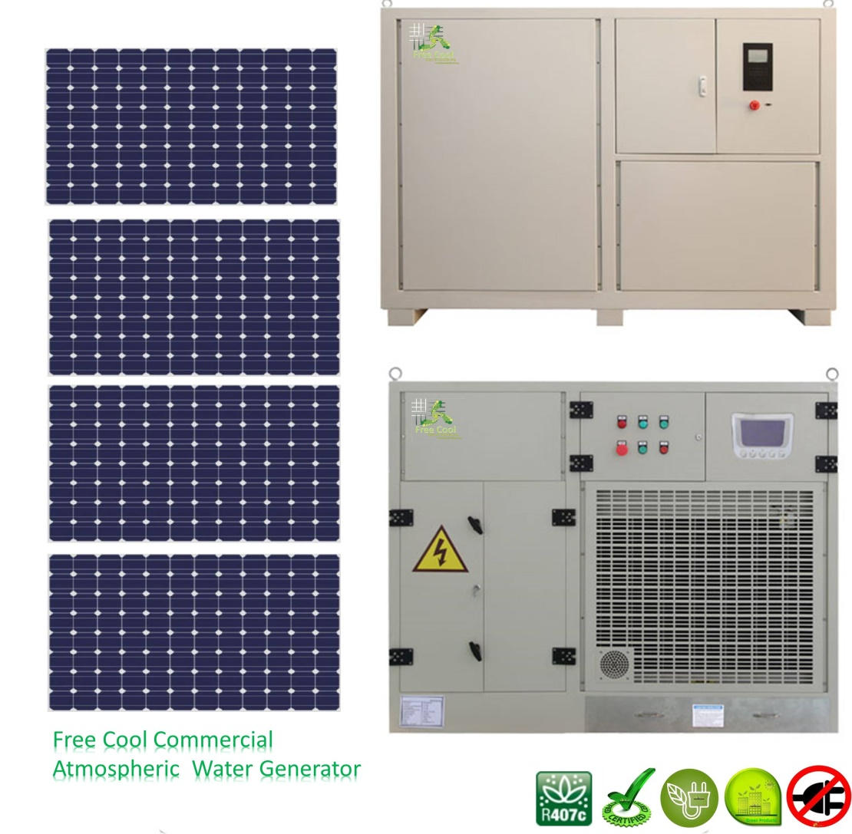
Model Number: FCWG600

Quick Details
- Brand Name: FREE COOL
- Specification: Normal
- Application: Commercial
- Output Voltage (V): 380V
- Load Power (W): 5500W
- Solar Power (W): 11520
- Work Time (h): 24hours
- Solar Panel: Monocrystalline
- Solar Brackets: aluminum alloy
- Solar Power: As Prime Power
- Features: Off grid, Low cost but high efficiency
- Batteries: Gel-Batteries
- Inverter: Inverter, controller and Battery charger 3 in 1
- Machine: Full Solar Atmospheric Water Generators
- Indication: Bottom tank water level indication

Imagine the ability to deliver safe drinking water in places where there is no power, no safe ground water, no available surface
water and no viable rain capture. Imagine doing this where there isn't even any salt water or where the salt water is too
contaminated to allow effective treatment.

FREE COOL Solar atmospheric water generators (FCAWGs) can e excellent options in hot, humid areas, especially where electricity
is unavailable or unreliable, and water quality is poor. They extract water from humid air by harnessing the power of the sun
instead of using electricity.

Specifications:
POWER SUPPLY | WATER DISPENSOR | RATED POWER OF AWG(KW) | WORKING POWER (KW) | SOLAR PANEL(PCS) (180-200W) | BATTERY STORAGE | INVENTER WITH CONTROLLER (KW) | THEORETICAL CAPACITY DAILY UNDER CONDITION(T30°C, R. H. 80%)
220v/50hz or 110V/60Hz (Single Phase) | 32L/D | 1.0 | 0.6 | 12 | 80AH*10 | 1.5 | 20-26L
220v/50hz or 110V/60Hz (Single Phase) | 100L/D | 2.0 | 1.4 | 21 | 150AH*14 | 2.5 | 70-75L
380V/50Hz (3 Phases) | 200L/D | 5.5 | 4.2 | 64 | 200AH*18 | 6.6 | 135L-150L

Filtration system
ITEM | SPECIFICATION | QUANTITY | SERVICE LIFE
Fabric Filter in Bottom Tank | Φ40 | 2 pcs | To be cleaned once a month
RO Booster Pump | EC-101-50 | 2 pcs
CTO Filter | 10`` | 5 pcs | Six months
Resin Filter | 10`` | 2 pcs | Six months
DOW-RO Membrane | TW-1812-50 | 2 pcs | Two years
UV | 11W | 3 pcs | 8000H or 12 months of the bulb
Water Output Pump | 15WG10-10 | 1 pcs

FCAWG's Specifications
Model | FCWG600 | FCWG600 A
Total Power Consumption (KW) | 4.8 | 5.6
Distribution Power (KW) | 5 | 6
Power Supply (3Phase 4line) | 380V,50Hz | 208V,60Hz
Water generation amount (t=30 ºC,Φ=80%). | 200L/day | 200L/day
Internal Water Storage Capacity (Liters) | 110 | 110
Power consumption of Centrifugal fan power (KW) | 0.2 | 0.4
Air volume (m^3/h) | 3000 | 3000
Input Power of Compressor (KW). | 4.66 | 5.1
Refrigerant | R407C or R22 | R22
Dimension (m) | 1.6*0.72*1.28 | 1.6*0.72*1.28
Weight (KG) | 320 | 320
Minimum wire diameter distribution (mm^2) | 3*2.5+1 | 3*4+1
Enter water pressure (MPa) | 0.1~0.6 | 0.1~0.6

Packaging
Packaging Details: | 1) Solar panels: 165cm (L)*146cm (W)*96cm(H)-this is package size, not installation size. 2) 200L/D AWG:170cm(L)*84cm(W)*146.5cm(H) 3) Electronic Box(Including inverter, batteries as a complete Cabinet):189cm(L)*70cm(W)*135cm(H)

Working principle:

We use Multitasking Electrics solar systems are totally different from others:

1) Off grid system. This is only one factory that could do with optimum MPPT on grid off solar system.
2) The individual developed hi-tech inverter can transport AC110-220V to the load DIRECTLY. Meanwhile invert energy to the electrical box where batteries stored for use of other appliances if needed.
3) The Air Water Generator (FCAWG) can work automatically if power supplied from inverter will be sufficient when the solar panels with enough sunshine at daytime. And works with power from batteries which might be charged during the daytime or sometimes both of them.
4) The equipped solar panels should be power enough for the FCAWG works at all the day and the batteries fully charged in the same time. And the full charged batteries can supply power to the FCAWG for at least 7 hours at night when the solar panels lose power.
5) Our inverter is with soft starting or variable frequency starting, with this, inverter sizing just need 1.5 times able to handle surge current during starting because our FCAWG is with compressor's starting while other factory's inverter need 3 times at least even 7.5 times. This way greatly saves your cost.

Ideal for remote locations:
· Remote cabins without a well. Most attractive where there is no grid power and where water must be hauled in.
· Industry and packaging where water shortages have caused work stoppage or lost revenue.
· Hotels in water scarce areas. Especially where they have lost room stay nights and/or reputation due to water shortages.
· Million $ homes which can be developed on land that could otherwise not be developed due to lack of water.
· Islands where overuse has eroded the freshwater lenses and destroyed wells. Especially islands with abnormally high cost
of power.
· Municipalities where lack of water supply is preventing issuance of new building permits.
· Homes and business in the hurricane zone who are at risk of loosing power and or water supplies for extended periods
of time.
· Well users in areas where dropping aquifer have degraded water quality and where drilling new wells has a low probability
of success.

