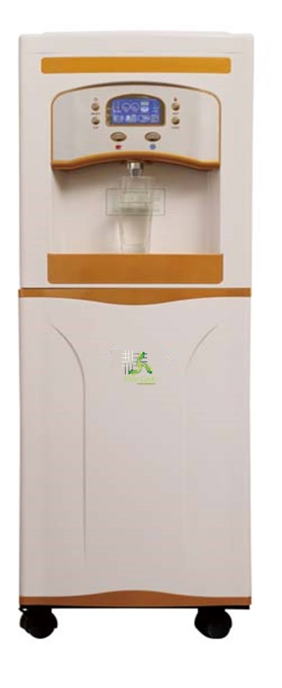
Model Number: FCWG6A

Quick Details
- Brand Name :Free Cool
- Type: Hot & Cold
- Installation: floor Standing
- Housing Material: Plastic
- Dimensions :40*41.5*112.4cm
- Power (W): 800
- Voltage (V): 220
- Water Making Capacity: 30L/D
- Water Making Production: 4 gallons/D
- Water: Hot& Cold Water
- Screen: Touch Screen
- Filters: 6 Stages Reverse Osmosis Filtration
- Water tank: SUS304 Stainless Steel Tank

Features:

•Super large LCD touch screen, user-friendly design, intuitive and convenient operation.
•The machine is a new, state of the art water generating machine which takes moisture out of thin air and turns it into pure drinking water.
•The multi-stage filtration system not only effectively removing the acid characteristics contain the necessary microelement and minerals.5 stages filtration system. The reverse osmosis is imported from USA and Korea.
•The multi-stage filtration system ensures the purest drinking water by using the “reverse osmosis “technology and the “ultra violet “lights in the circulation system.

"15L Counter Top Mini FCAWG with touch screen!"
Desktop Atmospheric Water Generator "HOT and COLD"!
Newest model, most compact and portable model.

Specification:
Item No.: | FCWG6A | Filters:  Free Cool AWG is equipped with a 12-stage Water-From  Air Filtration System that includes Charcoal Filters, Carbon Filters, a Mineral Filter, a Filmtec Reverse Osmosis Membrane, a Post Carbon Filter, and 3 Philips UV Sterilization Lamps. The system features a Stainless steel bottom water collection tank and a 3 Gallon Stainless steel top dispenser tank equipped with UV Spectrum Filters.  The Filmtec Reverse Osmosis Membrane Filter is the only filter you have to unpack from a sealed bag, and install in the unit.  No tools required.
Water Type: | Cold and Hot Water
Total Wattage: | 1000-1150W
Heating Wattage: | 500W
Cooling Wattage: | 500W
Cold Water Temperature: | 4-10°C
Temperature of Hot Water: | 75-93°C
Temperature of Hot Water:  Refrigerant Type: | 75-93°C
Temperature of Hot Water:  Refrigerant Type: | R22 —460g
Temperature of Hot Water:  Refrigerant Type: | R134A—450g
 | R407C—450g
Production Capacity | 30L/D with touch screen (30°C, humidity 80%)
Storage Capacity: | 12.5L SS(stainless steel)bottom tank:2.82L(Maximum) and 1.8L(Effective)
Purified water tank | 6.82L
Cold tank: | 2.76L
Temperature Range: | 15’C-40’C
Humidity Range: | 35%-95%
Noise Level: | <60DB
Net Weight: | 50KGS
Gross weight: | 52.6KGS
Machine size: | 40*41.5*112.4cm
Carton Packing Size(CM): | 46*43*116.5cm

