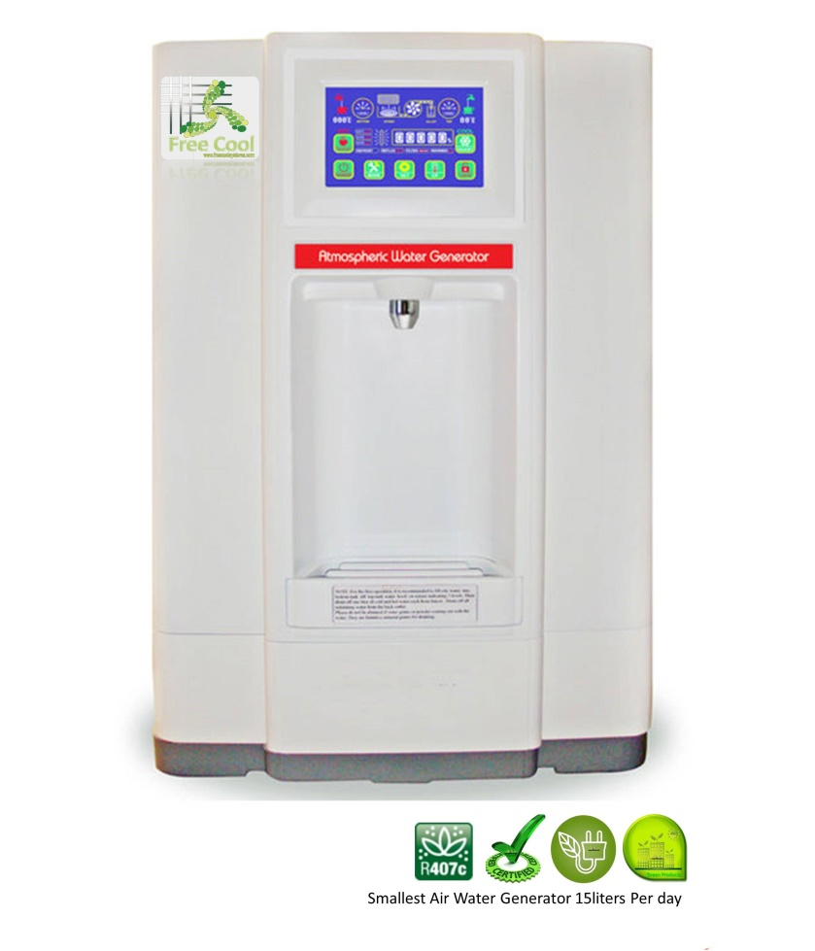
Model Number: FCWG9A

Quick Details
- Brand Name :Free Cool
- Type: Hot & Cold
- Installation: Desktop
- Housing Material: Plastic
- Dimensions (L x W x H (Inches):18*17*26inch
- Power (W): 800
- Voltage (V): 220
- Color: White
- Water Making Capacity: 15L/D
- Water Making Production: 4 gallons/D
- Water: Hot& Cold Water
- Screen: Touch Screen
- Filters: 6 Stages Reverse Osmosis Filtration
- Water tank: SUS304 Stainless Steel Tank

Features:

•Super large LCD touch screen, user-friendly design, intuitive and convenient operation.
•The machine is a new, state of the art water generating machine which takes moisture out of thin air and turns it into pure drinking water.
•The multi-stage filtration system not only effectively removing the acid characteristics contain the necessary microelement and minerals.5 stages filtration system. The reverse osmosis is imported from USA and Korea.
•The multi-stage filtration system ensures the purest drinking water by using the “reverse osmosis “technology and the “ultra violet “lights in the circulation system.

"15L Counter Top Mini FCAWG with touch screen!"
Desktop Atmospheric Water Generator "HOT and COLD"!
Newest model, most compact and portable model.

Specification:
Item No.: | FCWG9A | Filters:  Free Cool AWG is equipped with a 12-stage Water-From  Air Filtration System that includes Charcoal Filters, Carbon Filters, a Mineral Filter, a Filmtec Reverse Osmosis Membrane, a Post Carbon Filter, and 3 Philips UV Sterilization Lamps. The system features a Stainless steel bottom water collection tank and a 3 Gallon Stainless steel top dispenser tank equipped with UV Spectrum Filters.  The Filmtec Reverse Osmosis Membrane Filter is the only filter you have to unpack from a sealed bag, and install in the unit.  No tools required.
Water Type: | Cold and Hot Water
Total Wattage: | 800-950W
Heating Wattage: | 500W
Cooling Wattage: | 380W
Cold Water Temperature: | 4-10°C
Temperature of Hot Water: | 75-93°C
Refrigerant Type: | R22 —330g
Refrigerant Type: | R134A—330g
Refrigerant Type: | R407C—330g
Production Capacity | 15L/D with touch screen (30°C, humidity 80%)
Storage Capacity: | 8.8L SS(stainless steel  bottom tank:2.82L(Maximum) and 1.8L(Effective)
Purified water tank | 5L
Cold tank: | 1.6L
Temperature Range: | 15’C-40’C
Humidity Range: | 35%-95%
Noise Level: | <60DB
Net Weight: | 39Kgs
Gross weight: | 42Kgs
Machine size: | 45*43*66cm
Carton Packing Size(CM): | 48*48*74.5cm

