Free Cool on Grid DC Inverter
solar air-conditioner FCDC S-357 GW

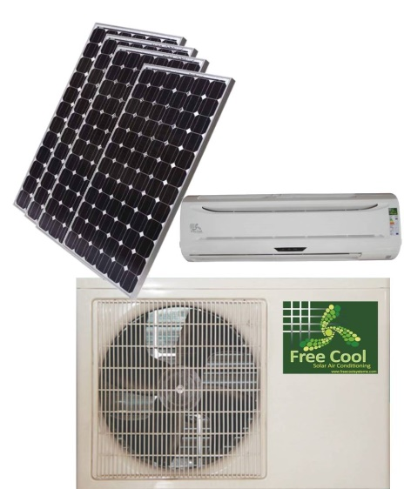
Specifications
100%solar energy, no electricity, environmental
Specifications

1.100% energy save by using pure solar power
2.no need any electricity
DC inverter ductless split air conditioners for home using
100% Solar Powered Air Conditioner Main features:

Off-grid mode
* 100% driven by solar energy, 100% energy saving
* 48V DC power drive, no inverter required, no AC power required.
* Deep cycle batteries as energy bank for overnight operation, over 8 hours’ back up time.
* DC inverter permanent magnet compressors
* DC brushless indoor and outdoor fan motors
* Lowest energy consumption, lowest noise level
* Lowest energy loss, SEER>19
* R134a CFC free refrigerant, Eco-friendly
* Short investment recovery period (1-3 years)
* Solar-mains power hybrid mode optional. When the energy in batteries is not enough to drive solar air conditioner (voltage < 45V), you can use a power adapter to drive solar air conditioner. The power adapter can transfer 220V/110V AC power to 48V DC for solar air conditioner using. Under hybrid mode, you can run 24Hr. per day without too much investment in solar panels and batteries. In addition, you can use the power adapter as a batteries charger.
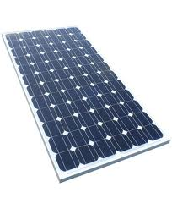
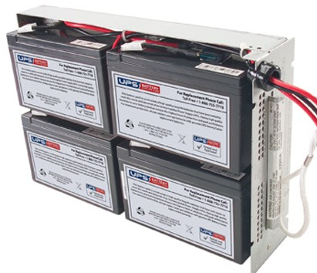
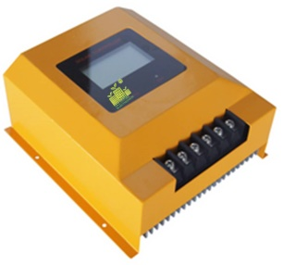
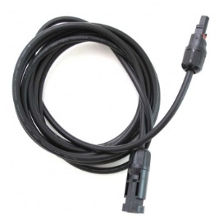

Solar Controller Battery Cables Solar Panels

Wall Mounted Type DC Solar Air-Conditioner
Power Supply：48VDC (42V to 54 V)
Model No. |  |  | FC DC S357 GW
Performance(R134a /R410a)
Capacity | Cooling | Btu/h | 12000
Capacity | Cooling | W | 3500
Capacity | Heating | Btu/h | 13500
Capacity | Heating | W | 3900
Noise | Indoor | dB(A) | ≤42
Noise | Outdoor | dB(A) | ≤52
Air Circulation |  | m³/h | 550
Suitable Area |  | m² | 12~22
EER |  | W/W | 4.55
 |  | Btu/h/w | 15.58
Power Consumption
Power Input | Cooling | W | 770
Power Input | Heating | W | 800
Rated Current | Cooling | A | 15.7
Rated Current | Heating | A | 16.3
Dimension
Indoor Unit | Net | mm | 815*288*210
Indoor Unit | Shipping | mm | 900*370*280
Outdoor Unit | Net | mm | 820*320*540
Outdoor Unit | Shipping | mm | 880*360*590
Weight
Indoor Unit | Net/Gross | kg | 11/13
Outdoor Unit | Net/Gross | kg | 42/45

Technical Parameter for Solar
Work time 24 hours for backup
100% solar A/C price（12000Btu）
no | name | specification | PCS | UNIT
1 | A/C | 12000BTU | 1 | PCS
2 | Battery | 12V 100AH | 24 | PCS
3 | SOLAR PANEL | 12V,150W | 36 | PCS
4 | OTHER PARTS | 120A Solar charger controller | 1 | PCS
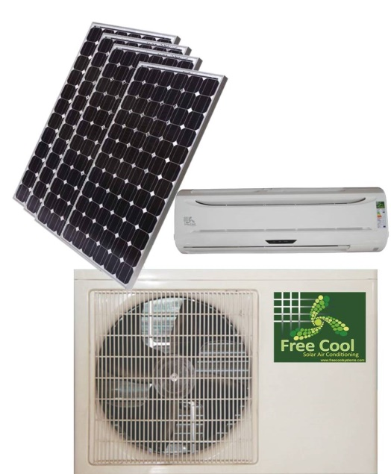
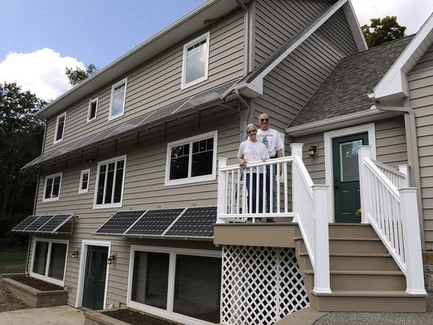

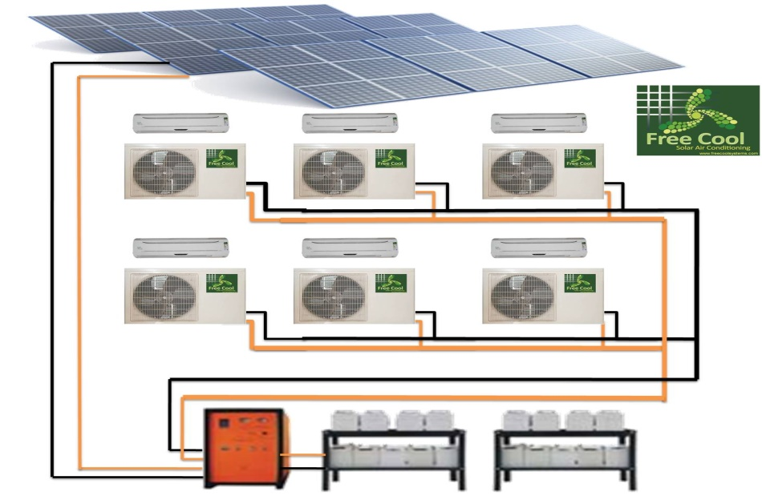

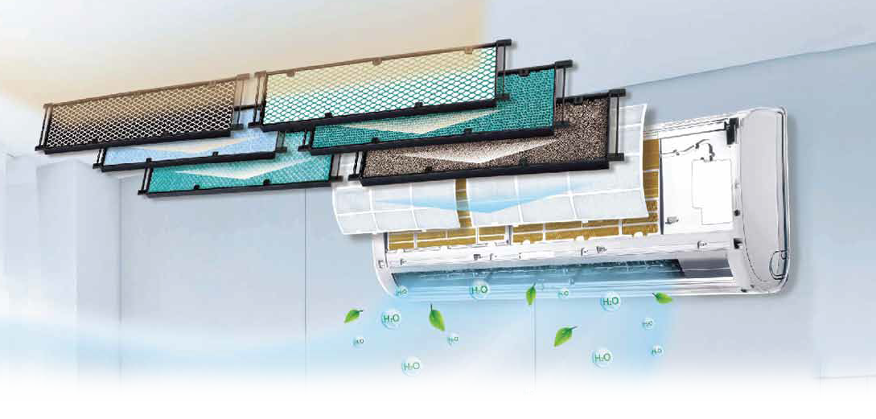

Thoroughly Purified Air
Creates a Healthy & Refreshing Space
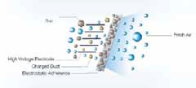
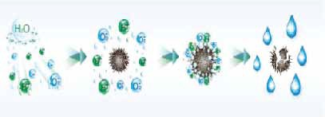
Cold Plasma Electrostatic Deducting Generator

Effective sterilization with more than 90% of  bacteria killed Odor removal Air nutrition improvement  with more negative oxygen ions | By making use of the principle of electrostatic adherence, it can effectively absorb the dust from the air. With detachable design, it is easy for complete cleaning to ensure the quality air.
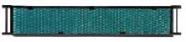
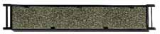
Photocatalytic Filter Active Carbon Filter

This filter is able to completely oxidize and degrade organic contaminants. It can effectively eliminate 99.9% of bacteria, viruses and unpleasant smell. | Activated carbon can effectively adsorb smoke, pet odors, and other unpleasant odors.
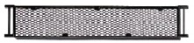
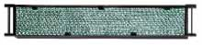
Catching Filter Silver Ion Filter

Catching extracted from green tea. It can effectively eliminate 95% of carcinogenic agents, such as staphylococcus, streptococcus, salmonella, etc. | Silver ion is able to sterilize 99% of bacteria by suppressing proliferation of mold and bacteria and preventing the cause of unpleasant odors.

