Benefits of Free Cool Solar Hybrid Air Conditioning

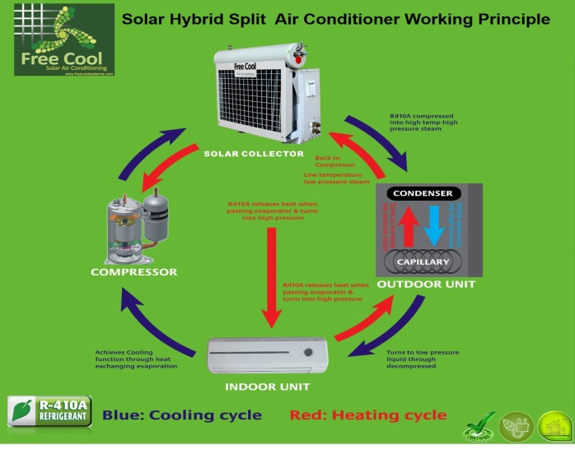
Air conditioning is one of the most significant costs to US households. Clean green energy has many benefits to the average Far North Queensland household. Once your new Free Cool Hybrid Solar Air-Conditioning system is installed, invite your friends to relax in the beautifully cooled atmosphere of your home and tell them how you saved as much as 60%* on your electricity bills. They too will be green - with envy!

Primary Benefits of Free Cool Solar Hybrid Air Conditioning with AIRE:
- Overall running costs are an greatly reduced when compared to conventional split system air conditioners
- Reverse Cycle - heats your home in winter as efficiently as it cools your home in summer
- Backed by Free Cool's 5 year warranty
- Exclusive hybrid engineering provides the duel benefit of free energy from sun with back-up from mains power
- meaning that the Free Cool Hybrid Solar Air-Conditioning system can operate in ambient temperatures, at
- night and on cloudy and rainy days
- Fully certified EER Rating with excellent yield results
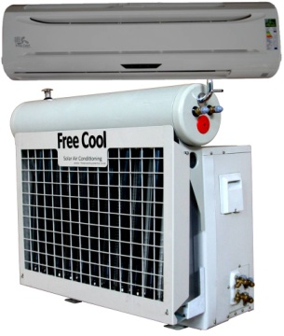
- Your family's contribution towards reducing carbon (greenhouse emissions) in to the atmosphere.
Conventional air-conditioning systems have been identified as a major contributor to environmental pollution

Advantages of Free Cool solar air conditioners

Advantages of Solar Air Conditioners is an innovation made to reduce the application of electricity for people or companies who installs such a system inside their offices or homes. Instead of using ordinary electricity to power up those conventional air conditioners which can be very expensive, this innovation allows you to save up on costs because it is powered largely by solar technology. Its always best to use in places where there an abundance of sunlight. This system will certainly become the most cost-effective solution in reducing the temperature in one place.

There are 2 types of solar air-con systems. These are be solar absorption air conditioning unit and solar desiccant units. This technique works once the solar technology that is gathered in to the solar collector or tube. The solar collector basically works much like solar hot water heaters. The force collected from your suns heat would be collected and stored from it. After which the thermal energy can be utilized in the solar powered chillers using Corn Glycol that was designed to power up the performance and life of a solar thermal system. The Free Cool tube collectors are recognized to be the most beneficial producer of solar domestic hot water which causes the absorption chillers to operate effectively and efficiently. The absorption chillers are powered by heat and make use of no harmful CFCs for example Freon and the like.It is used by cooling and heating water through the process of evaporation and condensation.

The chillers releases cold air by blowing it over a water-saturated material as well as the solar technology is used to increase the machines motors and fan. Also, solar absorption chillers are low maintenance and consumes if none only minimal levels of electricity which results in a substantial lowering of operating costs. In countries experiencing cold temperatures like snow, these solar air conditioners would likewise be able to give out heat which allows you not to use your heating system. Air con system provides many benefits such as being cost effective. Normally, it will take lots of money so that you can run an air conditioning system by having a cell.

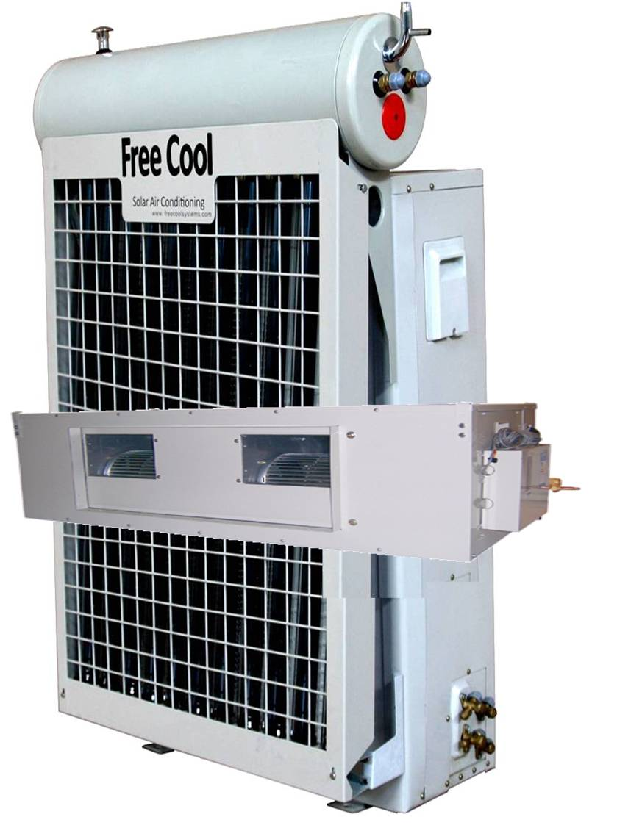
However with this new innovation, people can help to save up to 80% of costs in installation, electricity and maintenance. Another significant advantage is it doesn’t require solar power panels to run the tube solar thermal collectors are the ones collecting the thermal the suns energy and uses it to perform the environment conditioning system. Lets also take into account the main benefit of being beneficial to our environment because there are no chemicals employed in operating these solar air conditioning units. As compared to conventional air conditioning operating throughout the hottest time during the day which results to high power grid demands, solar air con offers if not none, minimal power demand even during its peak usage. It will ll then cause a significant drop in electricity costs, maintenance costs, fewer power outages and blackouts and reduced CFC or greenhouse gas emissions
.

