Free Cool Solar Hybrid Floor & ceiling type
Air Conditioning FCH (R) 130DW
Clean energy and renewable energy from the sun!
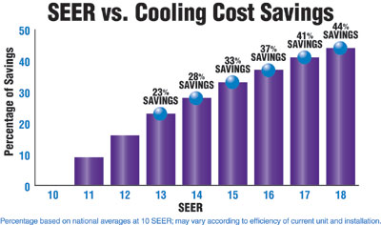
1. Specification for floor standing type: 36000btu, 41000btu, 48000btu
2. Function: cooling only or cooling & heating
3. Refrigerant: R410A
(R410A: comply with the environmental protection standard of EU, zero damage to the Ozone layer, enhancing the effect of heat exchange.)
4. Power supply: 220V 50/60HZ
5.Solar collector: vacuum tube
Features: Revolutionary technology
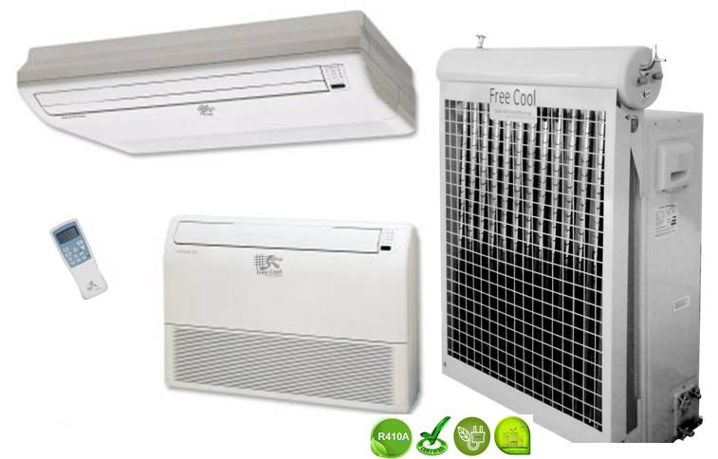
1. Free Cool solar hybrid air-conditioner at an economically competitive level could reduce Electricity costs by 30% up to 60%. (Depending on sunshine and temperature)
2 This would cut the growth of peak electric demand and ease the increasing Pressures on generating capacity, transmission, and distribution. The SEER exceed to 6.1, all of the solar air conditioner is A++ or A+++.
3. Healthy and comfortable, constant temperature and keeping air conditioner disease away. Automatic open and close dustproof air outlet.
4. We use a high efficient compact smaller compressor instead of standard compressors to run our system .Multit-fold heat exchanger and works together with our solar collector to saving electricity subsequently internal thread copper pipe and hydrophilic copper coil make the cooling stronger..

5. Free Cool With strong adaptability, our hybrid solar air conditioner can run at super low and high temperature from -7 to 63 centigrade.
6. Exceeding the national standards and applicable to all kinds of environment.
7, Free cool solar hybrid air conditioner have the humidification function, people will not feel thirsty in the room.
Why Free Cool hybrid solar air conditioner can save electricity?
It absorbs solar energy to heat the inside medium by using a vacuum solar collector. The refrigeration from the compressor goes through the copper coil inside the collector and undertakes a heat exchange. The refrigeration exchanges heat with the medium inside the solar collector will go through a cycle inside the system for cooling and heating.
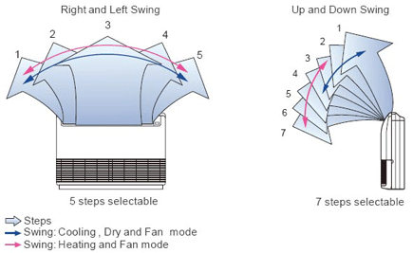
Secondly, it adopts a highly efficient heat-exchange system. The use of the internal thread pipe, hydrophilic aluminum fin and the optimal heat exchange system reduce energy loss, improve the overall efficiency and effectively ensure the performance. Therefore, Free Cool hybrid solar air conditioner is more convenient and energy-saving than regular air conditioner.
Thoroughly Purified Air
Creates a Healthy & Refreshing Space
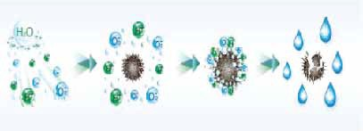
Cold Plasma

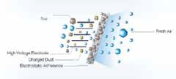
Electrostatic Deducting Generator

Technical Parameter:
Model |  |  | FC H (R)130DW
Voltage：220-240VAC, 1PH, 50/60Hz、R410A/R22
Performance Parameter
Capacity | Cooling | Btu/h | 36000
Capacity | Cooling | W | 10000
Capacity | Heating | Btu/h | 40000+1700
Capacity | Heating | W | 12000+500
Noise | Indoor Type | dB(A) | ≤53
Noise | Outdoor Type | dB(A) | ≤58
Air Circulation |  | m³/h | 1700
Suitable Area |  | m² | 42~67
EER |  | W/W | 3.87
 |  | Btu/h/w | 13.2
Power Consumption
Power Input | Cooling | W | 2400~2640
Power Input | Heating | W | 2470~2650+500
Rated Current | Cooling | A | 10.91~11.95
Rated Current | Heating | A | 11.23~12.05+2.2
Vacuum Tube | Diameter*Length*Quantity |  | 47mm*700mm*13
Volume
Indoor Type | N. W. | mm | 1672*673*243
Indoor Type | Shipping | mm | 1760*765*311
Outdoor Type | N. W. | mm | 950*355*835
Outdoor Type | Shipping | mm | 1140*460*910
Water Tank | Shipping | mm | 1120*400*400
Vacuum Tube | Shipping | mm | 1120*400*400
Weight
Indoor Type | N. W. /G. W. | kg | 40/43
Outdoor Type | N. W. /G. W. | kg | 73/76
Solar Collector | N. W. /G. W. | kg | 18/21

The Free Cool Solar Air Conditioner have integrated electro mechanical system utilizes the sun as an additional heat source to assist the energy needed to drive the cooling process of a typical air conditioning system which in turn reduces the electrical consumption required to run the compressor.
The Solar Air Conditioning System is similar to a regular A/C in that the refrigeration takes place by evaporating liquid with a very low boiling point. In both cases, when a liquid evaporates or boils, it takes some heat away with it, and can continue to do so either until the liquid is all boiled, or until everything has become so cold that the sub-zero boiling point has been reached.
The difference between the two is how the gas is changed back into a liquid so that it may be used again. A regular air conditioning system uses a compressor to increase the pressure on the gas, forcing it to become a liquid again through the use of the condenser coil. The change of state of the refrigerant, starts to take place approximately 2/3rd's of the way down the condenser. The Solar Air Conditioning System uses a different method. It uses the solar heat from the sun to superheat the refrigerant which enables the refrigerant to begin changing state at the top 2/3rd's of the condenser coil. By using this method it reduces the superheat of compression required to achieve the cooling process in the conventional cooling systems as well as utilizing more of the condenser cooling face of the coil. The conventional air conditioning system is only able to change a portion of the gas into a liquid state so as when the refrigerant enters into the metering device it is a saturated vapor. The Free Cool Solar A/C process allows more of the refrigerant to change state back into a liquid faster as well as allowing the transformation of more liquid into the metering device. While the high temperature and high pressure refrigerant steam coming out from the compressor passes the Solar panel collector, by absorbed solar power, the temperature will further increase from roughly 75℃ to 85℃. The super-heated cooling gas would largely improve the cooling effect when cooling exothermic into liquid in condenser.

For the purpose of better utilizing the heat gotten from solar power while reducing the electricity consumption, the condenser and evaporator have been specially designed to match the compressor by significantly increasing heat exchanging surfaces, much larger than those of regular Air Conditioner. In addition, by adopting state of the art controlling module, the whole Solar Air Conditioner System would work in the most efficient way, along with other factors, making the system achieve super high Energy Efficiency Ratio (EER) will be more.
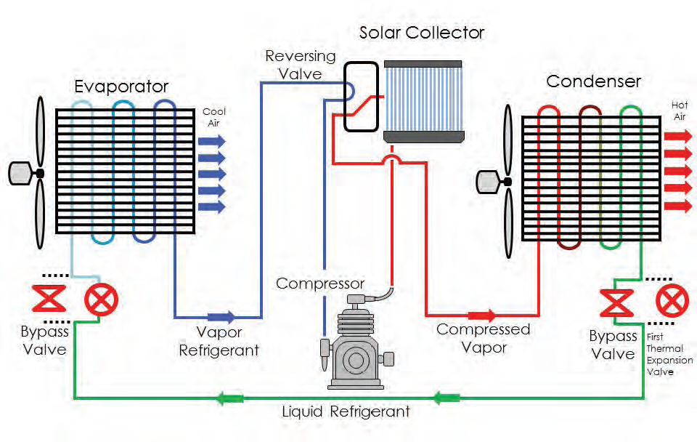

THE OUTDOOR SECTION OF THE A/C UNIT CONTAINS A COMPRESSOR WHICH USES THE MOST ELECTRICITY OF THE WHOLE SYSTEM
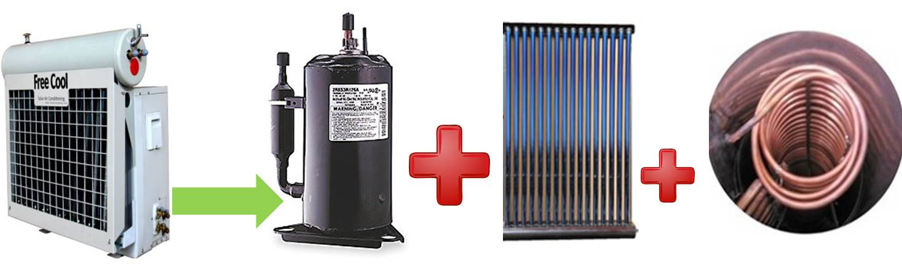
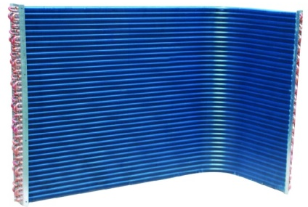
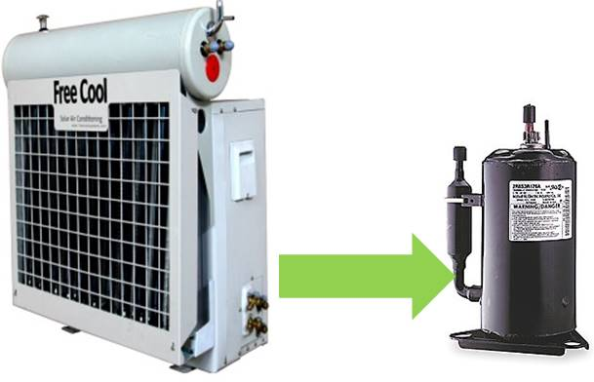
1- Stage Compressor and condenser coil.
2-Stage Compressor, Solar Vacuum Tube and copper coil Stay In 1st Stage Longer and Operate Between low power.

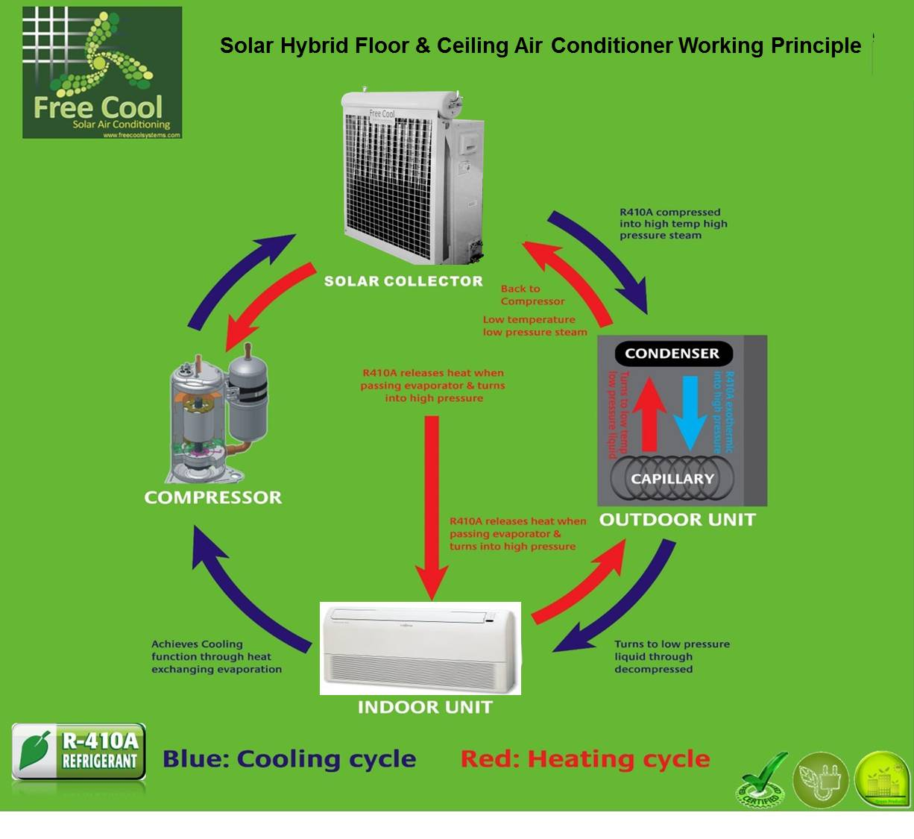

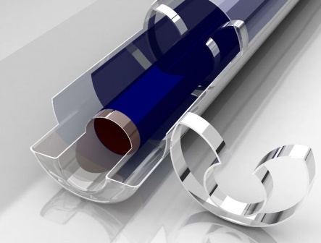
FEATURES
High efficiency all glass evacuated tube is the key component of solar collector. The evacuated tube is similar to a conventional Dewar flask and consists of two borosilicate glass tubes. This glass material has high chemical and thermal shock resistance. The outer surface of inner tube is coated with a sputtered solar selective material. This coated inner tube is closed at one end and sealed at the other end to the outer tube. The annular space between inner tube and outer tube is evacuated to virtually eliminate heat loss by conduction and convection.
Free Cool Solar vacuum tubes
