Free Cool Multi wall mounted type.
Solar Hybrid Air Conditioning FCH 1120FJ T2

EFFICIENT MULTI-ROOM SOLUTIONS
It’s never been easier or more economical to cool multiple rooms from a single outdoor unit.
Spec-Saving Convenience
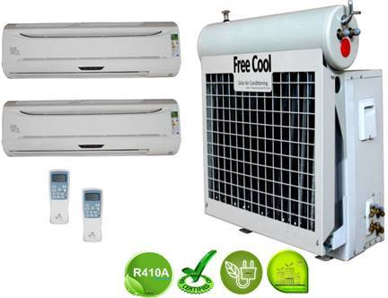
The Flex Multi-Split System allows you to operate up to four indoor units from just a single outdoor condensing unit. This gives you extra design flexibility and makes installation easier, which saves you money.
- Multi-Indoor with single out door BTU 24000 x12000=2
- fold heat exchanger, high-quality internal thread copper pipe and hydrophilic aluminum foil make the cooling capacity stronger.
- Anti-dust air filter makes air fresher.
- Digital e-Touch, convenient and electricity-saving, easier operation for elder people and kids.
- Fluorescent button, visible at night.
- Intelligent Defrosting.

Features: Revolutionary technology
1. Free Cool solar hybrid air-conditioner at an economically competitive level could reduce Electricity costs by 30% up to 60%. (Depending on sunshine and temperature)
2 This would cut the growth of peak electric demand and ease the increasing Pressures on generating capacity, transmission, and distribution. the SEER exceed to , all of the solar air conditioner is A++ or A+++.
3. Healthy and comfortable, constant temperature and keeping air conditioner disease away. Automatic open and close dustproof air outlet.
4. We use a high efficient compact smaller compressor instead of standard compressors to run our system .Mult-fold heat exchanger and works together with our solar collector to saving electricity subsequently internal thread copper pipe and hydrophilic copper coil make the cooling stronger..
5. Free Cool With strong adaptability, our hybrid solar air conditioner can run at super low and high temperature from -7 to 63 centigrade.
6. Exceeding the national standards and applicable to all kinds of environment.
7, Free cool solar hybrid air conditioner have the humidification function, people will not feel thirsty in the room.

Multiple Rooms Add up to Multiple Benefits
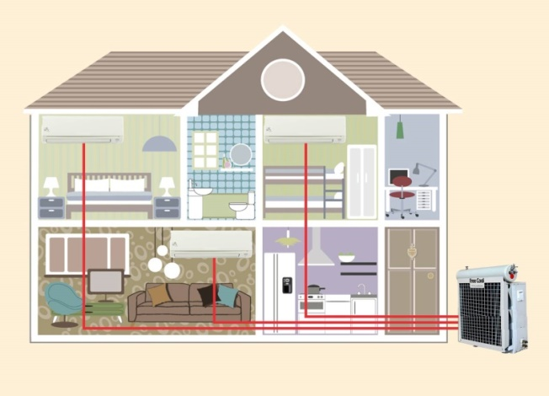
Flex Multi-Split Systems maximize the efficiency and cost savings of duct-free technology by providing:
Individual room temperature control – every indoor unit comes with its own remote control, so each room can be set to its own temperature.
All-season comfort option – you can choose cooling only or heat pump models that have both cooling and heating capabilities.
Easy Installation – not only is there no ductwork required, but the indoor units mount easily on virtually any

Technical Parameter:
Model No. |  |  | FCH 1120FJ T2
Power Supply：220-240VAC, 1PH, 50Hz
Performance
Capacity | Cooling | Btu/h |  | 24000*2
Capacity | Cooling | W |  | 7200*2
Capacity | Heating | Btu/h |  | 27000*2
Capacity | Heating | W |  | 7900*2
Noise | Indoor | dB(A) |  | ≤50
Noise | Outdoor | dB(A) |  | ≤58
Air Circulation |  | m³/h |  | 1050
Suitable Area |  | m² |  | 60~96
EER |  | W/W |  | 3.82
 |  | Btu/h/w |  | 13.03
Power Consumption
Power Input | Cooling | W |  | 3500~3740
Power Input | Heating | W |  | 3500~3760
Rated Current | Cooling | A |  | 15.91~17
Rated Current | Heating | A |  | 15.91~17.09
Vacuum Tube | Diameter*Length*Pcs |  |  | 47mm*1200mm*13
Dimensions
Indoor Unit | Net | mm |  | 985*325*230*2
Indoor Unit | Shipping | mm |  | 1160*400*330*2
Outdoor Unit | Net | mm |  | 950*360*1255
Outdoor Unit | Shipping | mm |  | 1140*460*1340
Water Tank | Shipping | mm |  | 1120*400*400
Vacuum Tube | Shipping | mm |  | 1270*280*210
Weight
Indoor Unit | Net/Gross | kg |  | 21/23
Outdoor Unit | Net/Gross | kg |  | 83/92
Solar Collector | Net/Gross | kg |  | 23/26

The Free Cool Solar Air Conditioner have integrated electro mechanical system utilizes the sun as an additional heat source to assist the energy needed to drive the cooling process of a typical air conditioning system which in turn reduces the electrical consumption required to run the compressor.
The Solar Air Conditioning System is similar to a regular A/C in that the refrigeration takes place by evaporating liquid with a very low boiling point. In both cases, when a liquid evaporates or boils, it takes some heat away with it, and can continue to do so either until the liquid is all boiled, or until everything has become so cold that the sub-zero boiling point has been reached.
The difference between the two is how the gas is changed back into a liquid so that it may be used again. A regular air conditioning system uses a compressor to increase the pressure on the gas, forcing it to become a liquid again through the use of the condenser coil. The change of state of the refrigerant, starts to take place approximately 2/3rd's of the way down the condenser. The Solar Air Conditioning System uses a different method. It uses the solar heat from the sun to superheat the refrigerant which enables the refrigerant to begin changing state at the top 2/3rd's of the condenser coil. By using this method it reduces the superheat of compression required to achieve the cooling process in the conventional cooling systems as well as utilizing more of the condenser cooling face of the coil. The conventional air conditioning system is only able to change a portion of the gas into a liquid state so as when the refrigerant enters into the metering device it is a saturated vapor. The Free Cool Solar A/C process allows more of the refrigerant to change state back into a liquid faster as well as allowing the transformation of more liquid into the metering device. While the high temperature and high pressure refrigerant steam coming out from the compressor passes the Solar panel collector, by absorbed solar power, the temperature will further increase from roughly 75℃ to 85℃. The super-heated cooling gas would largely improve the cooling effect when cooling exothermic into liquid in condenser.

For the purpose of better utilizing the heat gotten from solar power while reducing the electricity consumption, the condenser and evaporator have been specially designed to match the compressor by significantly increasing heat exchanging surfaces, much larger than those of regular Air Conditioner. In addition, by adopting state of the art controlling module, the whole Solar Air Conditioner System would work in the most efficient way, along with other factors, making the system achieve super high Energy Efficiency Ratio (EER) will be more.
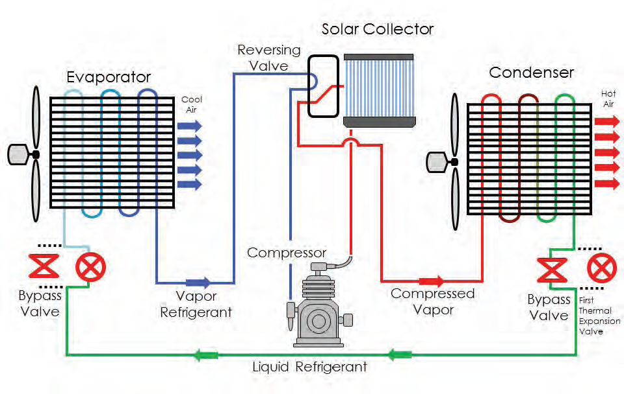

THE OUTDOOR SECTION OF THE A/C UNIT CONTAINS A COMPRESSOR WHICH USES THE MOST ELECTRICITY OF THE WHOLE SYSTEM
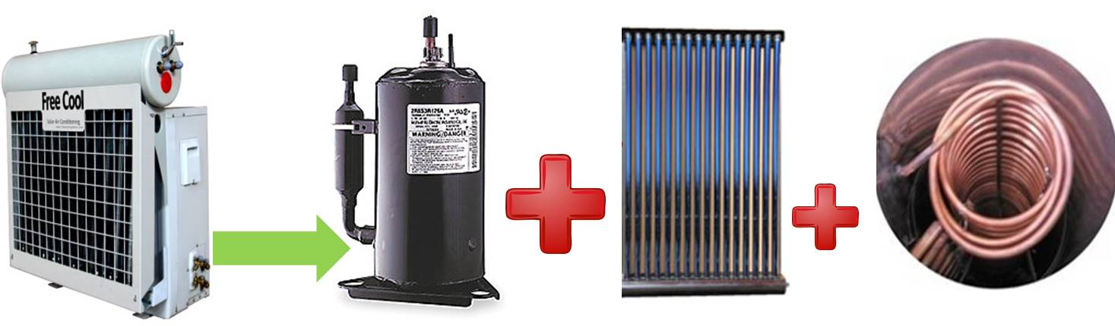
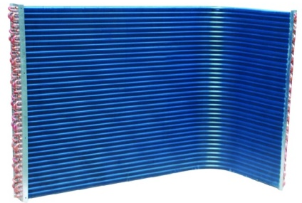
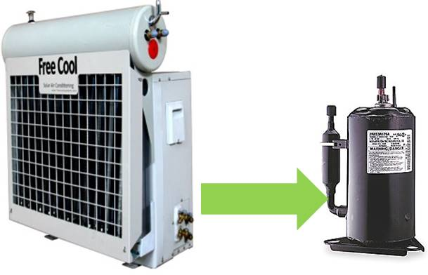
1- Stage Compressor and condenser coil.
2-Stage Compressor, Solar Vacuum Tube and copper coil Stay In 1st Stage Longer and Operate Between low Amps.

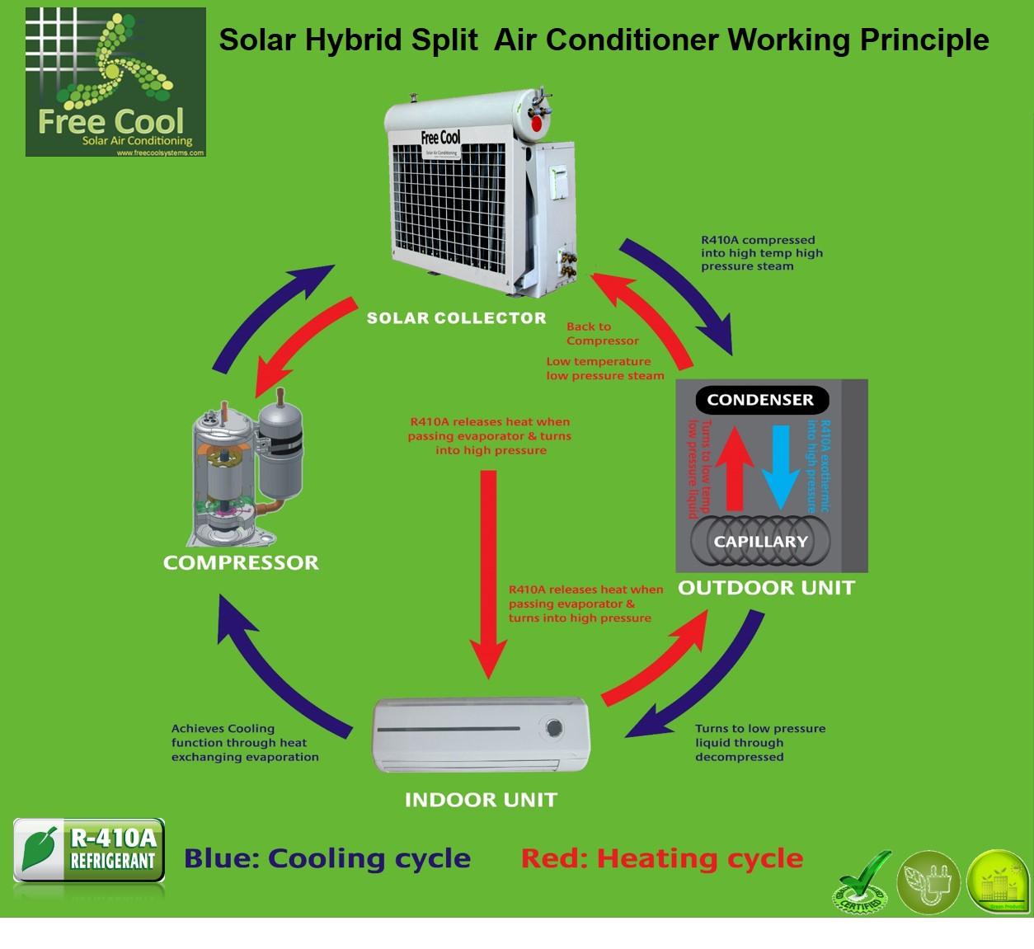

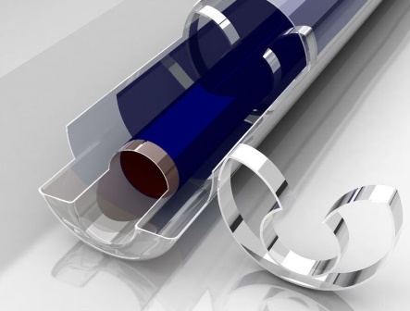
FEATURES
High efficiency all glass evacuated tube is the key component of solar collector. The evacuated tube is similar to a conventional Dewar flask and consists of two borosilicate glass tubes. This glass material has high chemical and thermal shock resistance. The outer surface of inner tube is coated with a sputtered solar selective material. This coated inner tube is closed at one end and sealed at the other end to the outer tube. The annular space between inner tube and outer tube is evacuated to virtually eliminate heat loss by conduction and convection.
Free Cool Solar vacuum tubes
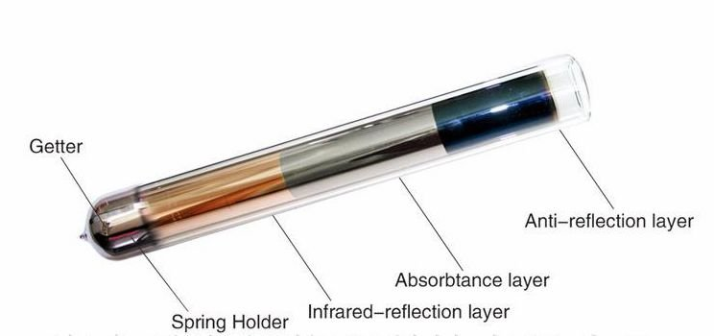
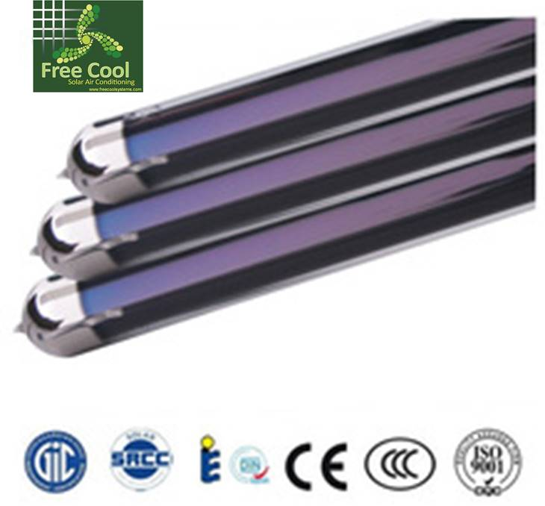
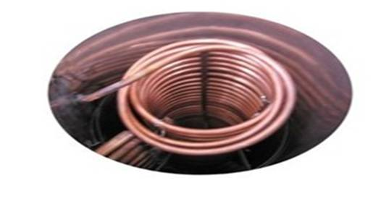

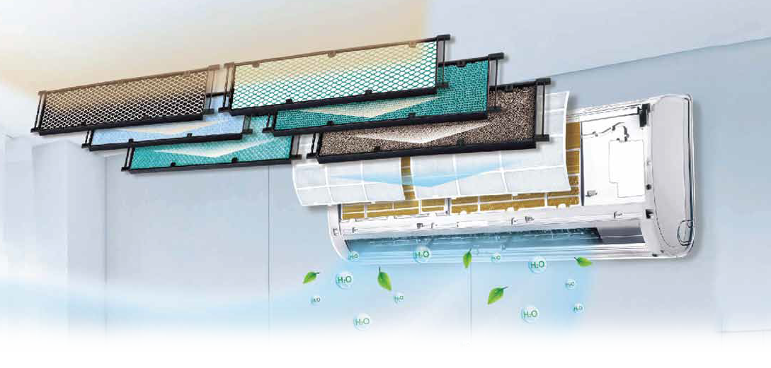

Thoroughly Purified Air
Creates a Healthy & Refreshing Space
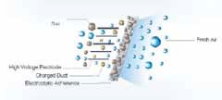
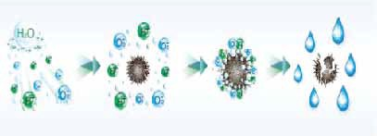
Cold Plasma Electrostatic Deducting Generator

Effective sterilization with more than 90% of  bacteria killed Odor removal Air nutrition improvement  with more negative oxygen ions | By making use of the principle of electrostatic adherence, it can effectively absorb the dust from the air. With detachable design, it is easy for complete cleaning to ensure the quality air.
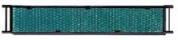
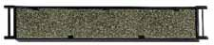
Photocatalytic Filter Active Carbon Filter

This filter is able to completely oxidize and degrade organic contaminants. It can effectively eliminate 99.9% of bacteria, viruses and unpleasant smell. | Activated carbon can effectively adsorb smoke, pet odors, and other unpleasant odors.
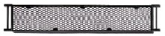
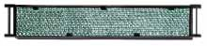
Catching Filter Silver Ion Filter

Catching extracted from green tea. It can effectively eliminate 95% of carcinogenic agents, such as staphylococcus, streptococcus, salmonella, etc. | Silver ion is able to sterilize 99% of bacteria by suppressing proliferation of mold and bacteria and preventing the cause of unpleasant odors.
Enjoy the Free Cool Peace 26 dB
Fresh and quiet Calm, mute and full enjoyment sound sleep of baby-hood

