Free Cool on Grid DC Inverter
solar air-conditioner FCDC-35GW/PV

Main Features
- No need any electricity if in sunshine day and can automatic switch to AC power at night, also can provide the power to grid electricity, save the cost every time.
- Adopt high quality and advanced Panasonic or Toshiba DC inverter compressor
- Remote control and easy installation
- Heating and cooling & cooling only functions
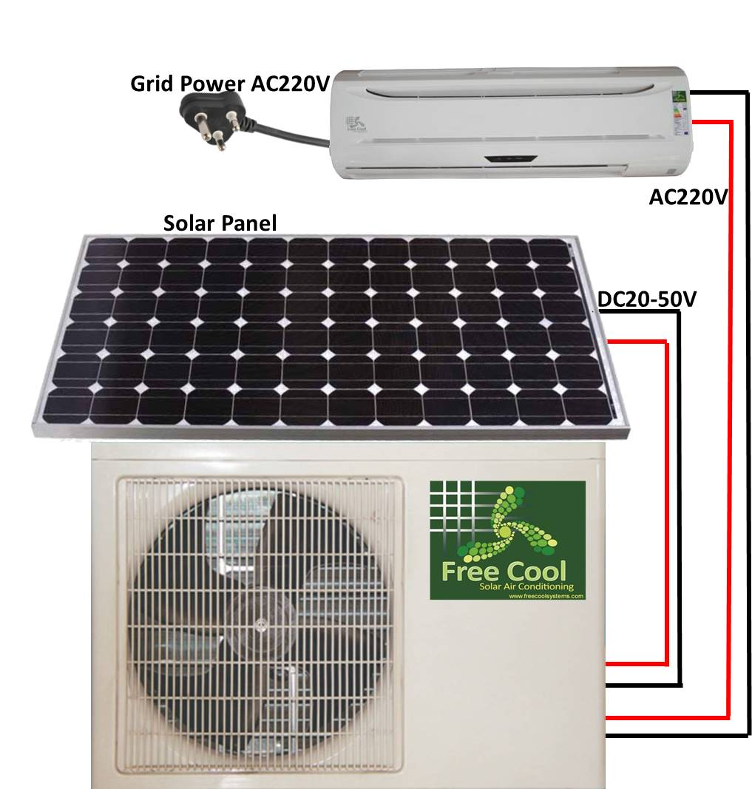
- Our solar air conditioner can provide with frequency 50 hz/60hz, refrigerant R410aVoltage 110v-380v
- CE, ROHS SASO and SAA certification
- Quite and Environment protection
- Super luxurious appearance and LED display
- DC inverter solar air conditioner can run smoothly at -10°C to 55°C
- Precise temperature control with ± 0.5°C from setting temperature
- Fast delivery and good after-sales service

Specifications
On-grid DC inverter solar air conditioner
Low electricity consumption
Wide voltage from 110V-380V
Environment friendly

Brief Introduction:
- On Grid DC inverter solar air conditioner takes the most leading technology in the world market.
- When in sunny day, the solar panel can provide the power together with on grid electrcity power
to provide to air conditioner for start running, when it running stable, the air conditioner can running just with the power from solar panel, so it no need any electrcity at this time.
- And when the air conditioner stop running at sunny day, the solar panel can produce the power to return to electrcity grid,then it can let the power meter reverse,then save the electcity cost.
- And when in cloudy day or night time, the air conditioner can automatic to switch to electrcity power.

Technical Parameter:

On Grid DC inverter type solar air conditioner
Model |  | FCDC-35GW/PV
 | BTU | 12000BTU
Capacity | Cooling | 3500W
Capacity | Heating | 3850W
Input power(w) |  | 650(400~1400)
Current(A) |  | 1.24~5.66
Power Supply |  | 220V/50/60Hz
Gas |  | R410A
Air flow (m³/hour) |  | 550
Solar panel (Mono) |  | 150W/30V
Noise(dBA) | Indoor | 40
Noise(dBA) | Outdoor | 53
Weight | solar panel(kg) | 14
Weight | Indoor(kg) | 13
Weight | Outdoor(kg) | 42
Dimension solar panel |  | 1450*680*35mm
Dimension ln unit |  | 795*265*215mm
Dimension Out unit |  | 760*260*540mm
Dimension solar panel Package |  | 1500*700*35mm
Dimension In Package |  | 840*265*360mm
Dimension Out Package |  | 880*335*590mm
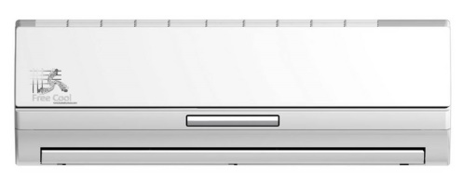

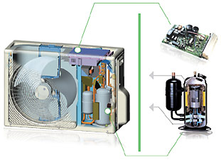
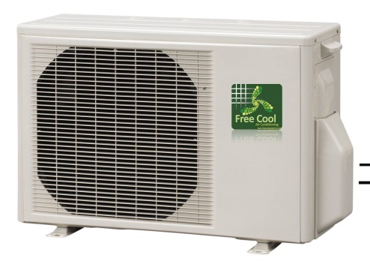
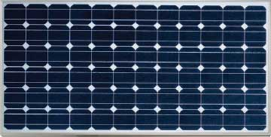

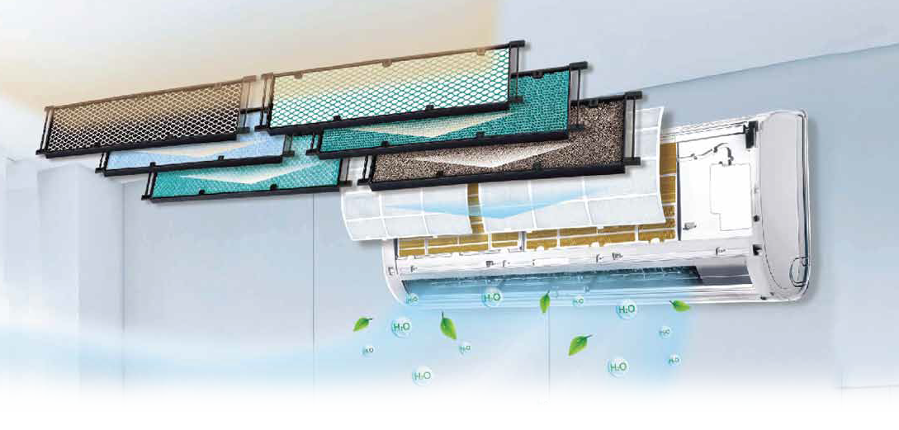

Thoroughly Purified Air
Creates a Healthy & Refreshing Space
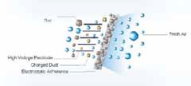
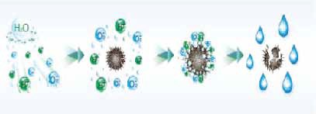
Cold Plasma Electrostatic Deducting Generator

Effective sterilization with more than 90% of  bacteria killed Odor removal Air nutrition improvement  with more negative oxygen ions | By making use of the principle of electrostatic adherence, it can effectively absorb the dust from the air. With detachable design, it is easy for complete cleaning to ensure the quality air.
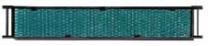
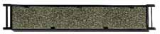
Photocatalytic Filter Active Carbon Filter

This filter is able to completely oxidize and degrade organic contaminants. It can effectively eliminate 99.9% of bacteria, viruses and unpleasant smell. | Activated carbon can effectively adsorb smoke, pet odors, and other unpleasant odors.
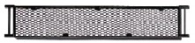
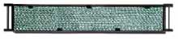
Catching Filter Silver Ion Filter

Catching extracted from green tea. It can effectively eliminate 95% of carcinogenic agents, such as staphylococcus, streptococcus, salmonella, etc. | Silver ion is able to sterilize 99% of bacteria by suppressing proliferation of mold and bacteria and preventing the cause of unpleasant odors.

