FREE COOL 100% Solar Powered Refrigerator
FCF-RM92 / FCF-KA76
Feature
High quality DC compressor CFC-free refrigerant (R-134a) Low power consumption Battery over discharge protection

- DC12V/24V automatic recognition
- AC/DC operated
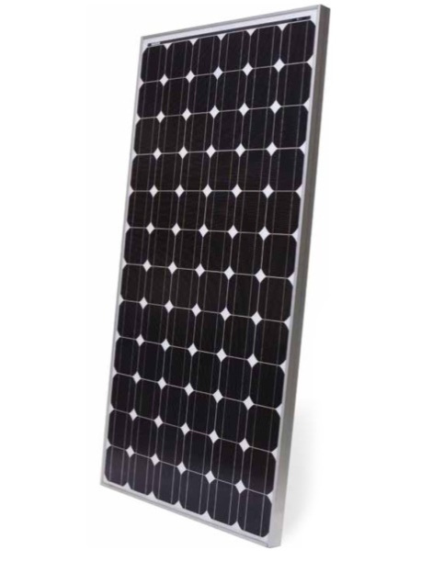
- 0℃-10℃ (32℉-50℉) for refrigerator compartment High temperature resistance and energy saving design

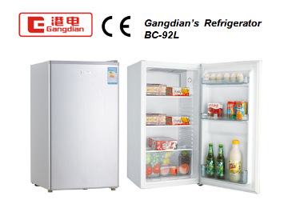
Applications
- Remote Homes
- Unreliable grid
- Micro-enterprises
- Boats and Marine
- Beverage Vending
- Remote Stores
- Ice Making
- Cabins
- Eco-Resorts , Farms
- Medical Clinics and Missionaries
- Disaster Preparedness
- Mobile Vendors
The Free Cool DC refrigerators and freezers. These high efficiency refrigerators and freezers have exceptionally low energy consumption, requiring smaller, less expensive power systems and low operating expense. High quality construction provides excellent reliability and long life.
Super-insulated cabinets feature of polyurethane insulation with powder-coated galvanized steel exterior and aluminum interior. A zero-maintenance, brushless, thermostatically controlled DC compressor operates on 12 or 24 VDC. A patented low-frost system reduces frost and moisture build up for low maintenance. These chest-style refrigerators and freezers are easy to clean using the drain hole at the bottom of the unit.
With thick insulation and refrigeration system optimized for solar, Free Cool refrigerators and freezers provide outstanding economical and reliable operation. Low energy consumption is the key that allows Free Cool refrigerators and freezers to be cost effectively powered from solar, wind, fuel cells or batteries. This technology allows refrigeration in remote locations where it was previously unavailable or prohibitively expensive.

FREE COOL 100% Solar Powered Refrigerator
FCF-RM92 / FCF-KA76

Model |  | FCF-RM92 | FCF-KA76
Power Consumption |  | 60W | 72W
Input Voltage |  | DC 12V / 24V | DC 12V / 24V
Work Temperature |  | <40℃ | <40℃
Capacity | Fridge Capacity | 82L (2.90 c.f.) | 76L (2.68 c.f.) (Bottom)
 | Freezer Capacity | 10L (0.35 c.f.) | 42L (1.48 c.f.) (Upper)
Product Size (mm) |  | 470 × 475× 815 | 470× 475 × 1165
Carton Size (mm) |  | 505× 535 × 855 | 505× 535× 1205
N.W./G.W.(KG) |  | 23 / 26 | 30 / 33

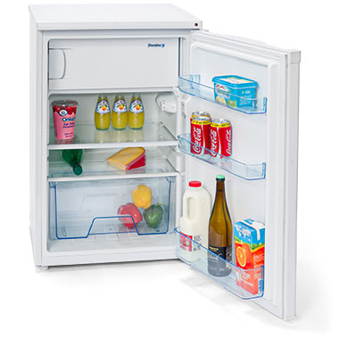

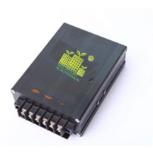

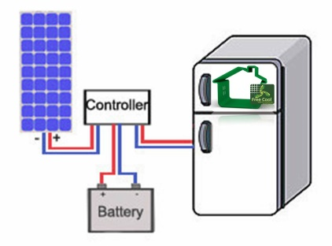
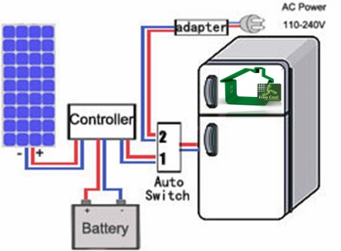

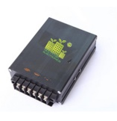
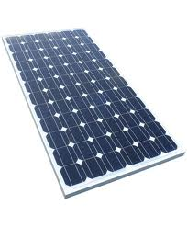
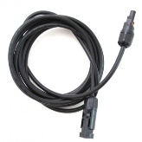
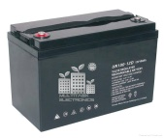
Solar Controller Gel Battery Accessories Solar Panel

